Lab01 – System solving in GeoGebra

# Content

Lab01 – System solving in GeoGebra 1

1. Content 1

2. Learning objectives 2

2.1. Learning materials 2

2.2. Exam objectives 2

2.3. Supportive objectives 2

2.3.1. GeoGebra Online 2

2.3.2. Self-support by GeoGebra 2

3. Exercises 2

3.1. Basic exercises 3

3.1.1. Solving 2 by 2 systems 3

3.1.2. Solving 3 by 3 systems 4

3.1.3. Solving systems with indexed variables 5

3.2. Bridging exercises 5

3.2.1. Crows on stakes 5

3.2.2. Paper cut 5

3.2.3. Strategy game 5

3.3. Contextual practice 6

3.3.1. Football competition in the Netherlands 6

3.3.2. Optimizing parallel renderings 6

4. References 7

4.1. Books 7

4.2. Basics 7

4.2.1. GeoGebra installs 7

4.2.2. Computational Intelligence engine 7

4.2.3. English maths dictionary 7

# Learning objectives

## Learning materials

ISBN **978-94 014 7495-5** (Animation Maths **(NE2021)**),

Chap2 Linear systems.

## Exam objectives

By the end of this lab you should be able to (pen and paper):

* Solve any (n equations by m variables) linear system
* Find the complete solution set of regular systems, as well as of underdetermined and inconsistent linear systems
* Apply the solve by substitution method for systems
* Apply the solve by elimination method for systems

We advise you to **make your own summary of topics** which are new to you.

## Supportive objectives

### GeoGebra Online

By the end of this lab you should be able to:

* Configure <https://geogebra.org/classic> its language, interface, defaults
* Enter various input either via its View/Algebra or View/Input Bar
* Display various graphs in its View/Graphics

### Self-support by GeoGebra

More specifically related to the above you should in GeoGebra:

* Solve any (n equations by m variables) linear system in GeoGebra
* Find and visualize the complete solution set of regular systems, as well as of underdetermined and inconsistent linear systems

# Exercises

Work individually and make sure that throughout the course of this lab, you re-save sufficiently your solution file on your local machine as

**1DAExx-AMP2-Lab0y-name.familyname**.GGB given **xx**=groupcode, **0y**=labindex

If not already on your machine, it is always clever to install a local version of **GeoGebra Classic 5.0 or 6.0** via <https://www.geogebra.org/download> which can save you time and frustration when on the go, or in case of bad connectivity!

## Basic exercises

For all underneath exercises do at least **one pen and paper attempt** in your own workbook, before checking your results in GeoGebra. In case of mismatches between your handwritten results and GeoGebra’s output, do not hesitate to seek assistance by your Lab attendant, as you are owner of your own learning.

### Solving 2 by 2 systems

Exercise 1: Solve the following system for x and y firstly by pen and paper, then verifying your answer by GeoGebra. Write down the complete solution set.

$$\left\{\begin{matrix}3x-5y=7 \\ 2x+9y=1\end{matrix}\right.$$

$$\left\{\begin{matrix}x=\frac{7+5y}{3} \\ 2x+9y=1\end{matrix}\right.$$

$$\left\{\begin{matrix}x=\frac{7+5y}{3} \\ 2∙\frac{7+5y}{3}+9y=1\end{matrix}\right.$$

$$\left\{\begin{matrix}x=\frac{7+5y}{3} \\ \frac{14+10y}{3}+9y=1\end{matrix}\right.$$

$$\left\{\begin{matrix}x=\frac{7+5y}{3} \\ \frac{14}{3}+\frac{10y}{3}+9y=1\end{matrix}\right.$$

$$\left\{\begin{matrix}x=\frac{7+5y}{3} \\ \frac{10y}{3}+\frac{27y}{3}=1-\frac{14}{3}\end{matrix}\right.$$

$$\left\{\begin{matrix}x=\frac{7+5y}{3} \\ \frac{37y}{3}=1-\frac{14}{3}\end{matrix}\right.$$

$$\left\{\begin{matrix}x=\frac{7+5y}{3} \\ y=(1-\frac{14}{3})∙\frac{3}{37}\end{matrix}\right.$$

$$\left\{\begin{matrix}x=\frac{7+5y}{3} \\ y=\frac{3}{37}-\frac{14}{37}\end{matrix}\right.$$

$$\left\{\begin{matrix}x=\frac{7+5y}{3} \\ y=\frac{-11}{37}\end{matrix}\right.$$

$$\left\{\begin{matrix}x=\frac{7+5∙\frac{-11}{37}}{3} \\ y=\frac{-11}{37}\end{matrix}\right.$$

$$\left\{\begin{matrix}x=\frac{7}{3}+\frac{1}{3}∙\frac{-55}{37} \\ y=\frac{-11}{37}\end{matrix}\right.$$

$$\left\{\begin{matrix}x=\frac{7}{3}+\frac{-55}{11} \\ y=\frac{-11}{37}\end{matrix}\right.$$

$$\left\{\begin{matrix}x=\frac{68}{37} \\ y=\frac{-11}{37}\end{matrix}\right.$$

* Rewriting both equations each solved for y, reveals its graphical interpretation.
$$\left\{\begin{matrix}y=\frac{1}{-5}\left(7-3x\right) \\ y=\frac{1}{9}\left(1-2x\right)\end{matrix}\right.$$

* Explain the geometrical meaning of this system in the cartesian plane.
* Finally display this graphical interpretation in GeoGebra to verify.

Exercise 2: Solve the following system for x and y firstly by pen and paper, then verifying your answer by GeoGebra. Write down the complete solution set.

$$\left\{\begin{matrix}3x-5y=7 \\ -6x+10y=1\end{matrix}\right.$$

$$\left\{\begin{matrix}y=\frac{3x}{5}-\frac{7}{5} \\ y=\frac{3x}{5}-\frac{1}{10}\end{matrix}\right.$$

Deze vergelijkingen zijn evenwijdig.(zelfde rico.)

* Now rewrite both equations each solved for y, to reveal the graphical interpretation of it. $\left\{\begin{matrix}y=\frac{3x}{5}-\frac{7}{5} \\ y=\frac{3x}{5}-\frac{1}{10}\end{matrix}\right.$
* Explain the geometrical meaning of this system in the cartesian plane.

evenwijdig

* Finally display this graphical interpretation in GeoGebra to verify.
* How do we call in maths such a systems with an empty solution set?

Exercise 3: Solve the following system for x and y firstly by pen and paper, then verifying your answer by GeoGebra. Write down the complete solution set.

$$\left\{\begin{matrix}3x-5y=7 \\ -6x+10y=-14\end{matrix}\right.$$

$$\left\{\begin{aligned}y=\frac{3x}{5}-\frac{7}{5} \\ y=\frac{3x}{5}-\frac{7}{5}\end{aligned}\right.$$

* Now rewrite both equations each solved for y, to reveal the graphical interpretation of it. $\left\{\begin{aligned}y=\frac{3x}{5}-\frac{7}{5} \\ y=\frac{3x}{5}-\frac{7}{5}\end{aligned}\right.$
* Explain the geometrical meaning of this system in the cartesian plane.

Samenvallend

* Finally display this graphical interpretation in GeoGebra to verify.
* How do we call in maths such a systems with an infinite solution set?

### Solving 3 by 3 systems

Exercise 4: Solve the following system for x and y and z firstly by pen and paper, then verifying your answer by GeoGebra. Write down the complete solution set.

$$\left\{\begin{matrix}3x-5y+2z=7 \\ 2x+9y-5z=1 \\ 7x+y-4z=3\end{matrix}\right.$$

$$\left\{\begin{matrix}3x-5y+2z=7 \\ 2x+9y-5z=1 \\ y=3-7x+4z\end{matrix}\right.$$

$$\left\{\begin{matrix}3x-5∙(3-7x+4z)+2z=7 \\ 2x+9∙(3-7x+4z)-5z=1 \\ y=3-7x+4z\end{matrix}\right.$$

$$\left\{\begin{matrix}3x+35x-20z-15+2z=7 \\ 2x+27-63x+36z-5z=1 \\ y=3-7x+4z\end{matrix}\right.$$

$$\left\{\begin{matrix}38x-18z-15=7 \\ -61x+31z+27=1 \\ y=3-7x+4z\end{matrix}\right.$$

$$\left\{\begin{matrix}38x-18z-15=7 \\ z=\frac{-26+61x}{31} \\ y=-7x+4z+3\end{matrix}\right.$$

$$\left\{\begin{matrix}38x-18∙(\frac{-26+61x}{31})-15=7 \\ z=\frac{-26+61x}{31} \\ y=-7x+4z+3\end{matrix}\right.$$

$$\left\{\begin{matrix}38x-18∙(\frac{-26+61x}{31})-15=7 \\ z=\frac{-26+61x}{31} \\ y=-7x+4z+3\end{matrix}\right.$$

* Rewriting all equations each solved for z by GeoGebra, will reveals its graphical interpretation in the GeoGebra/3DGraph. Do display each equation expressed by z in the GeoGebra/3DGraph to understand their nature.
* Explain the geometrical meaning of this system in the cartesian space.

### Solving systems with indexed variables

Exercise 5: Just solve the following system for x1 and x2 and x3 firstly by pen and paper, then verifying your answer by GeoGebra **obligatory making use of these indexed variables in GeoGebra**. Provide its complete solution set.



## Bridging exercises

### Crows on stakes

Exercise 6: In my field a fixed number of crows makes use of a fixed number of stakes. If one crow sits on every stake, there are twenty crows remaining without a seat. If the crows are somehow social they sit in pairs on a stake. In which case ten stakes remain empty.

Question: determine both the number of crows and of stakes in my field.

### Paper cut

Exercise 7: Two friends, Els and Fiona, are halving a rectangular sheet of paper by using scissors. Els ends up with two congruent paper rectangles each measuring a perimeter of 40 cm. Fiona on the other hand remains with two congruent paper rectangles each with a perimeter of 50 cm. Although both took off with congruent initial sheets.

Question: find the perimeter of the initial sheet of paper?

### Strategy game

Exercise 8: In an on-line strategy game your avatar was given 12500 points to cover his transport and food. However, as soon as he undertakes his virtual journey his transport costs 1000 less than expected and he spends half of the estimated cost on food. By the end of the day he spent in total 2250 points less than expected.

Question: how much did the he allow for transport?

## Contextual practice

### Football competition in the Netherlands

Exercise 9: Please find the final ranking of the football league in the Netherlands as displayed in the table below. All 18 teams each played a match against one another: a home-match and an out-match. For a victory a team received 3 points, for a draw 1 point and no points for a lost game.

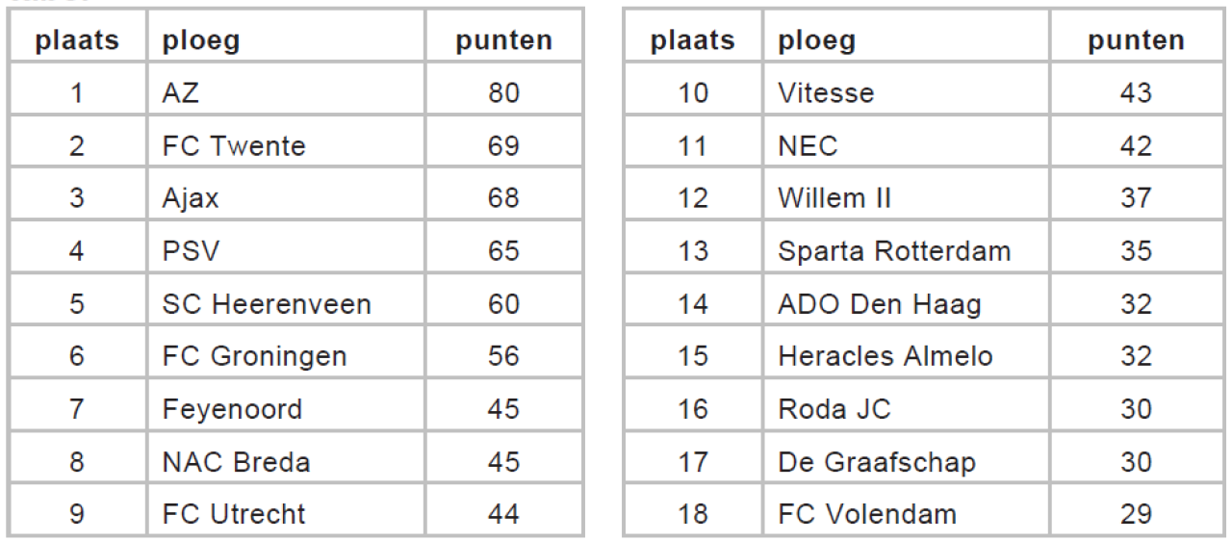

Question: how many of the matches in this competition ended in a draw?

### Optimizing parallel renderings

Exercise 10: In a render farm we want three types of modeled objects (x, y and z) to be subsequently rendered by 3 successive substages of a graphical pipeline.

We know on average their render times for

* model x as 3 min in stage A, 11 min in stage B and 27 min in stage C
* model y takes 15 min in stage A, 5 min in stage B and 6 min in stage C
* model x occupies 12 min stage A, 14 min stage B and 5 min stage C

Question: how many models of each type (x, y and z) are to be rendered in 8 hours in order to have each substage A, B and C fulltime working?

# References

## Books

ISBN **978-94 014 7495-5** (Animation Maths **(NE2021)**),

Chap2 Linear systems.

## Basics

### GeoGebra installs

<https://www.geogebra.org/download>

### Computational Intelligence engine

<http://www.wolframalpha.com>

### English maths dictionary

<http://www.mathwords.com>